Shot No.1a | 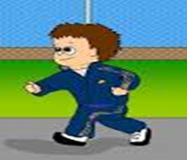 | Type of Shot  LS | Dialogue/Voice over – Sound – Camera Movement  See a spec of Alex jogging by the sports hall. | Timing  3 Sec
Edit:

Shot No.1b | 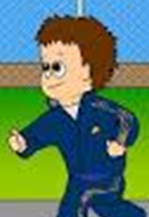 | Type of Shot  MS | Dialogue – Sound – Camera Movement  Camera gets closer for a Medium shot of Alex jogging by the sports hall. | Timing  3 Sec
Edit:

Shot No.1d | 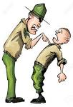 | Type of Shot  MS | Dialogue – Sound – Camera Movement  After Lenny and Billy popped up at Alex earlier they shout at Alex saying we’re going to show you what real training is. | Timing  5 Sec
Edit:

Shot  No.2a  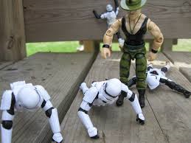 |  | Type of Shot | Dialogue – Sound – Camera Movement  Alex is stressing out while Billy and Lenny are shouting at him going “keep going”, “did we tell you to stop”. | Timing
Shot  No.2b  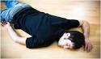 |  | Type of Shot | Dialogue – Sound – Camera Movement  Alex falls down and faints. | Timing
Shot No.3a |  | Type of Shot  CS | Dialogue – Sound – Camera Movement  Alex pathetically doing push ups Lenny bends over to him passing him a snickers saying “your pathetic when your Hungry”. | Timing  6 Sec
Edit:

Shot  No.3b |  | Type of Shot | Dialogue – Sound – Camera Movement  Alex then starts to eat the snickers when Billy says “eat your snickers”. | Timing
Shot No.3c |  | Type of Shot  CI | Dialogue – Sound – Camera Movement  After Billy say’s better Alex then responds with “Better” then he begins pushing himself to the limit. | Timing  3 Sec
Edit:

Shot  No.3d |  | Type of Shot | Dialogue – Sound – Camera Movement  Voice pops up saying “You’re not you when you’re hungry. Snickers get some NUTS”. | Timing

